CS 148 Database Design for the Web

James Edwards

Assignment Four

Maxine Davis Glass Art

Version <1.0>

|  |  |  |  |
| --- | --- | --- | --- |
| Time Log | | | |
| Date | Time Spent (in hours) | Description | Author |
| 10/10/13 | 2.0 | First Version of Software Requirements | James Edwards |
|  |  | My estimated time to complete assignment _____25____ hours | James Edwards |
| 10/21/13 | 1.0 | Created home page (nav, header, and footer) | James Edwards |
| 10/21/13 | 2.5 | Created needed .php files (connect.php, etc.) | James Edwards |
| 10/22/13 | 1.5 | Attempted to figure out include file | James Edwards |
| 10/22/13 | 3.0 | Made the register form function | James Edwards |
| 10/23/13 | 1.0 | Set up email confirmation | James Edwards |
| 10/23/13 | 4.0 | Learned html 5 new style, created order form | James Edwards |
| 10/24/13 | .5 | Planned out tables needed in database | James Edwards |
| 10/24/13 | 1.0 | Created needed tables in database | James Edwards |
| 12/24/13 | 7.0 | Wrote SQL statements in php for register and order (including m2m relation table statements), created admin page | James Edwards |
| 10/26/13 | 4.5 | Learned CSS and altered pages appropriately | James Edwards |
| 10/28/13 | 1.5 | Wrote necessary text and added image updated project spec document | James Edwards |
|  | 27.5 | Total hours | James Edwards |
|  |  |  |  |
|  |  |  |  |
|  |  |  |  |
|  |  |  |  |
|  |  |  |  |
|  |  |  |  |
|  |  |  |  |
|  |  |  |  |
|  |  |  |  |
|  |  |  |  |
|  |  |  |  |
|  |  |  |  |

Table Of Contents

Software Requirements Specifications 4

Introduction 4

Purpose 4

Definitions, acronyms, and abbreviations 4

Overview 4

Overall Description 5

Data Dictionary 5

E-R Diagram 6

Schema 7

Story Board 9

Specific requirements 9

# Software Requirements Specifications

## Introduction

### Purpose

The purpose of this website is to allow users to register to the Maxine Davis Glass Art database. Users can also select the attributes for a piece of art and order it. The intended audience for this website is anyone who would like to become an owner of hand made glass art made by Maxine Davis.

### Definitions, acronyms, and abbreviations

HTML – Hypertext markup language – used to define your content.

PHP – Personal Home Page – language that helps to customize html.

CSS – Cascading Style Sheets – used to define the look of a web site.

W3 Validation – refers to both Html and CSS validation tool provided by the W3c.org. the html validator is located at:

<http://validator.w3.org/>

with the CSS validator located at:

<http://jigsaw.w3.org/css-validator/>

### Overview

The rest of this document contains an overall description of the Maxine Davis Glass Art web site.

## Overall Description

This site will allow users to choose whether they would like a bowl or a plate, what color they would like it to be, and if they would like their item in gift-wrap. This is available to the user through the order form where they can also choose a name for the order and enter any special instructions they would like Maxine Davis to know. The user can also register on the register page to become a member of Maxine Davis Glass Art. By entering their information they will be added to the database and be eligible for special services. On the admin page, primarily for the Maxine Davis to view there is a display of the tables contained within the database. From these tables she can see what orders have taken place and which customer has ordered them. She is also able to view any users who have registered.

### Data Dictionary

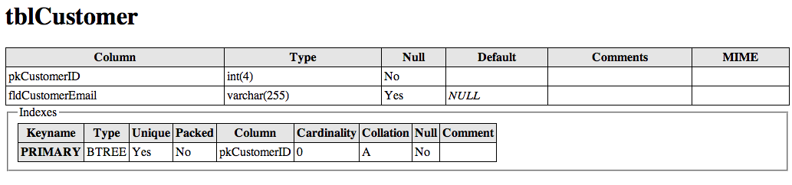

### 

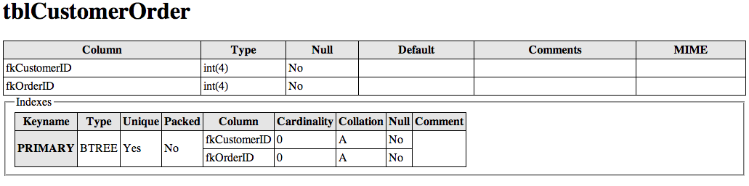

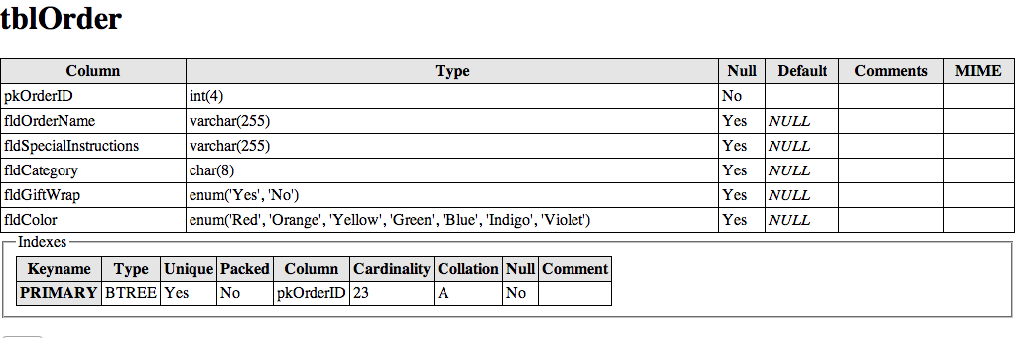

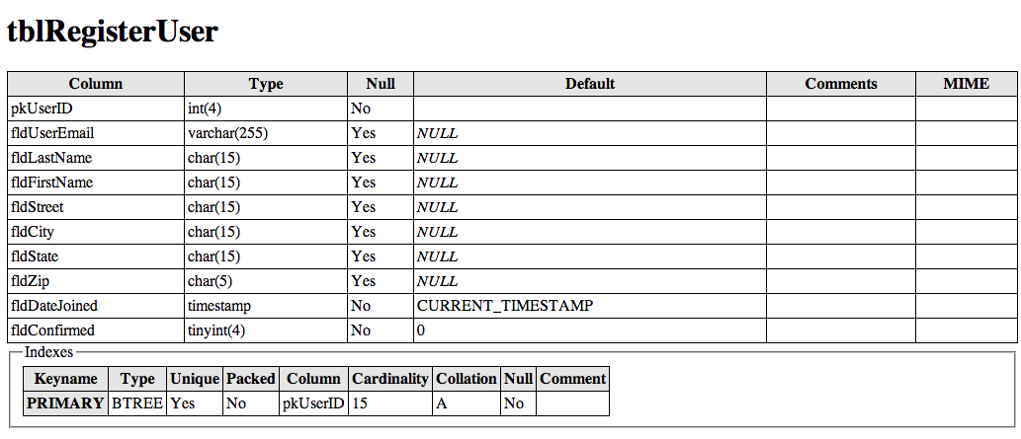

### E-R Diagram

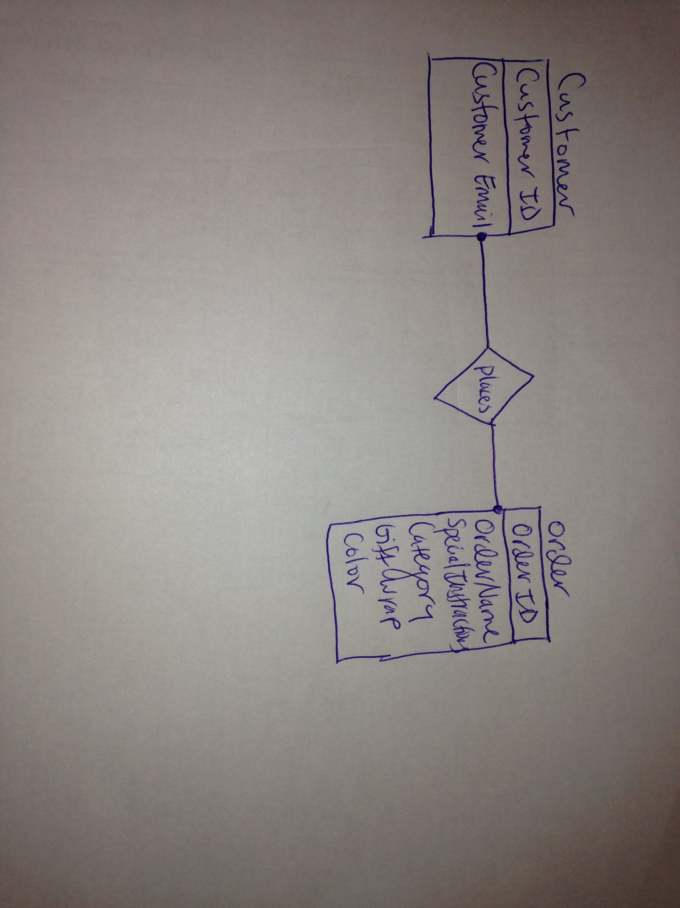

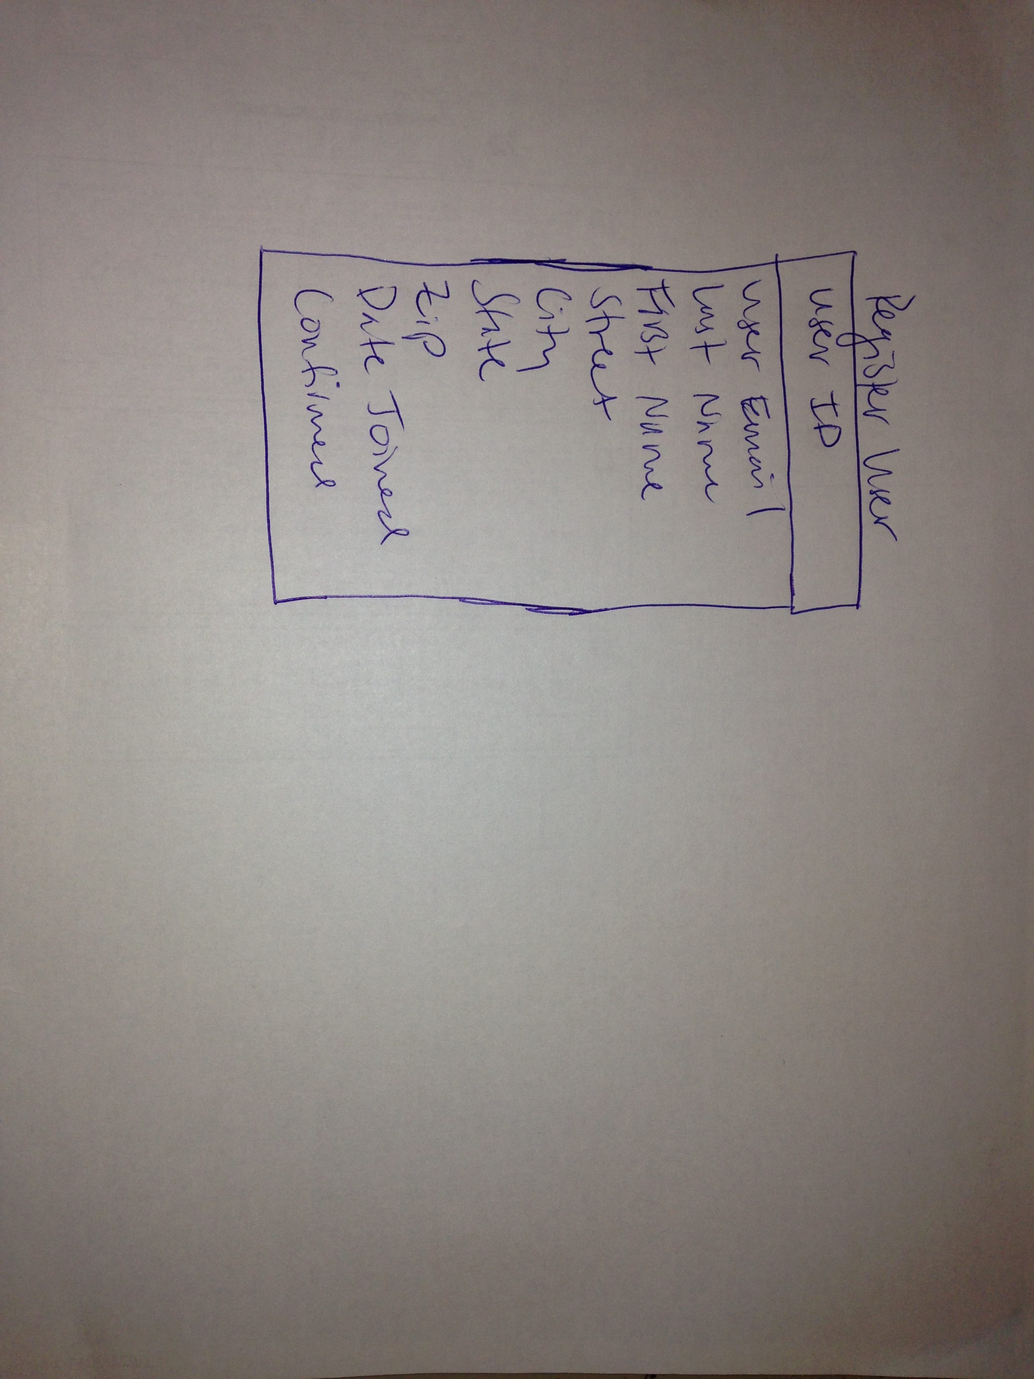

### 

### Schema

CREATE TABLE tblCustomer(

pkCustomerID INT(4) NOT NULL PRIMARY KEY auto_increment,

fldCustomerEmail VARCHAR(255) DEFAULT NULL

);

CREATE TABLE tblCustomerOrder(

fkCustomerID INT(4) not null references tblCustomer(pkCustomerID),

fkOrderID INT(4) not null references tblOrder(pkOrderID),

PRIMARY KEY (fkCustomerID,fkOrderID)

);

CREATE TABLE tblOrder(

pkOrderID INT(4) NOT NULL PRIMARY KEY auto_increment,

fldOrderName VARCHAR(255) DEFAULT NULL,

fldSpecialInstructions VARCHAR(255),

fldCategory CHAR(8),

fldGiftWrap ENUM(‘Yes’,’No’),

fldColor ENUM(‘Red’,’Orange’,’Green’,’Blue’,’Indigo’,’Violet’)

);

CREATE TABLE tblRegisterUser(

pkUserID INT(4) NOT NULL PRIMARY KEY auto_increment,

fldUserEmail VARCHAR(255) DEFAULT NULL,

fldLastName CHAR(15),

fldFirstName CHAR(15),

fldStreet CHAR(15),

fldCity CHAR(15),

fldState CHAR(15),

fldZip CHAR(5),

fldDateJoined timestamp NOT NULL DEFAULT CURRENT_TIMESTAMP,

fldConfirmed TINYINT(4) NOT NULL DEFAULT ‘0’

);

### 

### Story Board

### photo 1.png

## 

## Specific requirements

1. *Location* – all necessary files allowing for the website to function will be stored in my UVM public folder
2. *Html Validation* – All pages will pass W3C Html validation for html 5.
3. *CSS Validation* – All pages will pass W3C 3.0 CSS validation.
4. *Meta Information* – All pages will contain a proper title tag, Meta tags (author, character set and description).
5. *CSS* – all pages will have a linked style sheet.
6. *Navigation* – a menu will be located on each page of the website which will allow users to navigate effectively
7. *Content* – Each page will effectively show and describe each individual page of art so that the user will have enough information about the product to decide whether they will submit an order online.
8. *Browser compatibility* - This site will be checked on Firefox, Safari, Chrome, (IE is not supported)
9. *File Names* –

Home.php - This is the home page. Here is a basic description of the website and a brief descrition of who Maxine Davis is.

Register.php – This is the form the user enters their information into so that they can be added to the user table in the database. Instructions for doing this are located on this page.

Order.php – This is the form that allows users to place orders. Once doing so their order will be added to the order table and they will be added to the customer table.

Admin.php - Allows primarily Maxine Davis to view the database tables to obtain relevant information.

Header.php – Displays header of website.

Footer.php – Displays footer of website.

Nav.php – List of links that allows navigation between pages.

Top.php – file in which style sheet is linked.

Connect.php – file needed to allow for connection to Maxine Davis Glass Art database.

Confirmation.php – file needed to allow for user to confirm registration.

MailMessage.php – file needed to send email messages to user.

Style.css – Style sheet which dictates display of forms.

Validation_functions.php – file needed to validate user input into forms.